Access Token

🔑 What Is an Access Token?
# Source: AI Source: Provided by: [Data Path: Persons Table -> ID Column: 1, Name_En Column: Motasem Essam] -> From: [Chatgpt (GPT‑5 Mini)] on [1/20/2026]
An Access Token is a temporary digital key used by an application to access protected resources (like APIs or user data) on behalf of a user.

✅ Simple Definition:
# Source: AI Source: Provided by: [Data Path: Persons Table -> ID Column: 1, Name_En Column: Motasem Essam] -> From: [Chatgpt (GPT‑5 Mini)] on [1/20/2026]
An Access Token proves that the user (or app) has permission to access a specific resource for a limited time.

🧠 Real-Life Analogy:
# Source: AI Source: Provided by: [Data Path: Persons Table -> ID Column: 1, Name_En Column: Motasem Essam] -> From: [Chatgpt (GPT‑5 Mini)] on [1/20/2026]
Think of a hotel keycard:
- You check in (log in), and get a keycard (access token)
- It opens only your room, not the whole hotel
- It expires when you check out (token expiration)

🛠️ Where It Comes From
# Source: AI Source: Provided by: [Data Path: Persons Table -> ID Column: 1, Name_En Column: Motasem Essam] -> From: [Chatgpt (GPT‑5 Mini)] on [1/20/2026]
Usually issued by:
- 🔐 OAuth 2.0 servers (e.g., Google, Facebook, GitHub)
- 🔧 Your own backend auth system (e.g., with JWT)

🔄 How Access Tokens Work
# Source: AI Source: Provided by: [Data Path: Persons Table -> ID Column: 1, Name_En Column: Motasem Essam] -> From: [Chatgpt (GPT‑5 Mini)] on [1/20/2026]
- User logs in
- Server generates an access token (e.g., JWT or opaque string)
- Client stores it (in memory, cookie, or localStorage)
- Client sends it with each request:
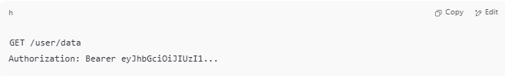
GET /user/data
Authorization: Bearer eyJhbGciOiJIUzI1...

- Server verifies the token before giving access

📦 What Does an Access Token Contain?
# Source: AI Source: Provided by: [Data Path: Persons Table -> ID Column: 1, Name_En Column: Motasem Essam] -> From: [Chatgpt (GPT‑5 Mini)] on [1/20/2026]
If it's a JWT (self-contained token), it may include:
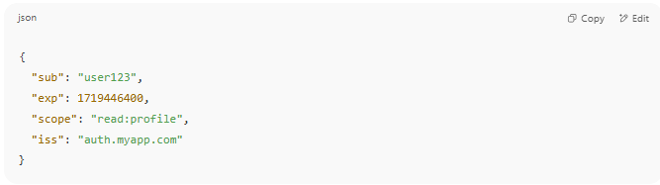

{
"sub": "user123",
"exp": 1719446400,
"scope": "read:profile",
"iss": "auth.myapp.com"
}

If it's opaque (non-readable), it just looks like:
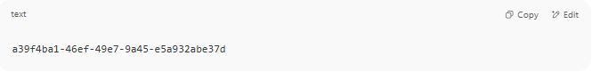
a39f4ba1-46ef-49e7-9a45-e5a932abe37d

...and must be validated by a database or token server.

⏳ Expiration & Security
# Source: AI Source: Provided by: [Data Path: Persons Table -> ID Column: 1, Name_En Column: Motasem Essam] -> From: [Chatgpt (GPT‑5 Mini)] on [1/20/2026]
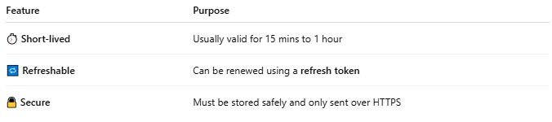

Feature | Purpose
⏱ Short-lived | Usually valid for 15 mins to 1 hour
🔁 Refreshable | Can be renewed using a refresh token
🔒 Secure | Must be stored safely and only sent over HTTPS

🧪 Access Token in Practice
# Source: AI Source: Provided by: [Data Path: Persons Table -> ID Column: 1, Name_En Column: Motasem Essam] -> From: [Chatgpt (GPT‑5 Mini)] on [1/20/2026]
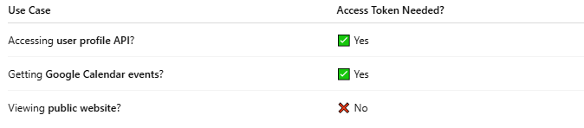

Use Case | Access Token Needed?
Accessing user profile API? | ✅ Yes
Getting Google Calendar events? | ✅ Yes
Viewing public website? | ❌ No

📌 Summary
# Source: AI Source: Provided by: [Data Path: Persons Table -> ID Column: 1, Name_En Column: Motasem Essam] -> From: [Chatgpt (GPT‑5 Mini)] on [1/20/2026]
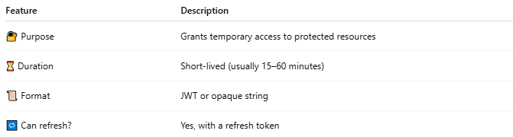

Feature | Description
🔐 Purpose | Grants temporary access to protected resources
⏳ Duration | Short-lived (usually 15–60 minutes)
📜 Format | JWT or opaque string
🔁 Can refresh? | Yes, with a refresh token

